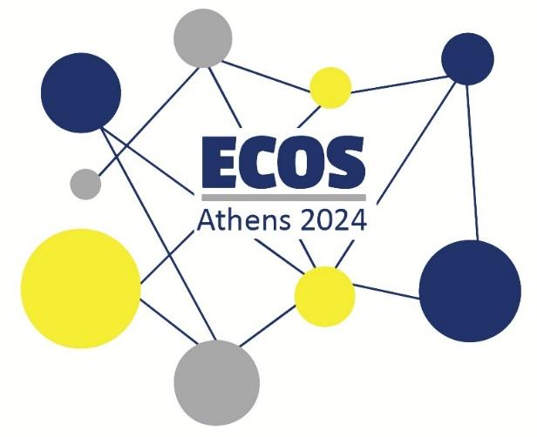

**European Conference of Speech-to-Text Interpreters**

**ECOS ATHENS 2024 ● Book of Abstracts**

**Foreword**

**Prosvasis Universal Access Research and Innovation Lab for Technology, Society and the Arts** is proud to be the host of this year’s edition of the European Conference of Speech-to-Text Interpreters (ECOS) that takes place in **Athens, Greece**, **from July 26th to July 28th 2024**.

The aim of the ECOS conference is to bring together researchers, practitioners, language service providers and other stakeholders within the field of Speech-to-Text Interpreting (STTI). At ECOS 2024, we focus on the recognition of STTI as a profession, the disambiguation of the field, its bonds with Audiovisual Translation, Interpreting and Sign Language Interpreting, the interaction of Speech-to-Text Interpreters with the audience/users and the communities they serve, the technology behind STTI, and the relevant educational background needed for professionals in the area.

Being hosted in Greece, ECOS offers a great opportunity for the country to bring the need for STTI to the surface. It also hopes to provide the grounds for countries with no or very little representation in the field to share their stories and be involved in a constantly growing community of professionals. ECOS aims to bring together professionals and the users of the service, and thus invites representatives of both to attend and share their knowledge and experience in Athens.

**Keynote Speech on STTI Training**

|  |  |
| --- | --- |
|  | **Dr Carlo Eugeni**  Associate Professor in Audiovisual Translation  at the University of Leeds,  Live Subtitling and STTI Training Specialist  [C.Eugeni@leeds.ac.uk](mailto:C.Eugeni@leeds.ac.uk) |

**STTI training - teaching the undefined, defining the untaught**

This speech aims to provide a thorough understanding of Speech-to-Text Interpreting (STTI) training.

In particular, I will begin with a brief overview of key definitions to underscore the importance of precise terminology in effective teaching. This will highlight how clarity in terms contributes to better educational outcomes, and show how partial definitions of the matter lead to partial training.

Following this, I will delve into the history of STTI research to trace its origins and evolution. This offers insights into its current practices and future directions, and will naturally lead into an examination of the history of teaching STTI, reflecting on how educational approaches have evolved alongside the growing understanding of the profession.

Drawing comparisons with simultaneous and consecutive interpreting, I will highlight the similarities in skills and challenges faced by what, for now, are still different professions.

Next, I will discuss the essential skills required by STTI professionals, detailing the competencies necessary for success in this demanding and ever-evolving field. I will also explore the diverse contexts in which STTI professionals operate, from educational settings to public services, emphasising the versatility and adaptability of their skills.

The core of the speech will be divided into three parts: intralingual, interlingual, and multilingual STTI, each focusing on specific pedagogical strategies and challenges. The session will conclude with an overview of what I feel is a crucial skill, reaching MARS. This includes a description of the skill, a discussion of its importance, and the illustration of an online open-access tool which can be easily implemented in both formal and informal education.

**KEYWORDS**

STTI, training, teaching, simultaneous interpreting, consecutive interpreting, multilingual

**BIO**

Dr Carlo Eugeni is the programme leader of the MA Audiovisual Translation and Localisation at the [University of Leeds](https://www.linkedin.com/company/university-of-leeds/), where he teaches live subtitling, media access services, and conference interpreting. He launched the International Symposium on Live Subtitling, co-funded the International Association of Respeaking onA.I.R., wrote the first book and Ph.D. thesis on the topic, and designed the live subtitling self-assessment tool MARS. Carlo has researched and published in the fields of live subtitling, conference interpreting, and subtitling strategies; and is co-editing a book for [Routledge](https://www.linkedin.com/company/routledge/) entitled Teaching Interpreting and Live Subtitling. In 2018, he received an honorary award by the Italian Association of Cochlear Implant Users APIC for his commitment in promoting the empowerment of deaf people through live and pre-recorded subtitling. He was Intellectual Output Leader of the Erasmus+ project LTA on live subtitlers and T2V on Easy-to-Read validators and facilitators, and is currently serving as a partner in the Erasmus+ project CCUV on Easy Italian writing and the Horizon project iDEM on accessibility to the decision-making process; and as a member of the experts group on accessibility in the metaverse for the UN International Telecommunications Unit.

**Keynote Speech on STTI, Disability and Audiovisual Translation**

|  |  |
| --- | --- |
|  | **Dr Emmanouela Patiniotaki**  Academic and Researcher on Accessibility,  Access Services/STTI practitioner,  Founder and CEO of ATLAS E.P.,  Managing Director of Prosvasis Research Lab  [askatlasep@gmail.com](mailto:askatlasep@gmail.com) |

**Bonds among STTI, AVT and Disability**

Among the various forms of Translation and Interpreting, similarities can be traced in the skills required for professionals to deliver them effectively, the means utilised for their preparation and delivery, as well as the profile of their recipients. Although more traditional types of Interpreting may seemingly not share much with the most popular types of Audiovisual Translation, i.e. conventional subtitling and dubbing, when serving the same or similar *skopos* (Vermeer, 1978), they seem to have a lot to borrow from each other.

Based on their purpose, with the common ground between the two being identified as the fact that both forms of translation and interpreting can develop a dynamic relationship between the items to be translated and their audience, this presentation aims to show where the two fields meet. From professionals’ skills, to users’ needs and how these can (or should) be taken into consideration in the way the services are provided, AVT and STTI seem to have a lot to gain from a combined analysis of their characteristics with disabled audiences in mind.

But it is not only at the level of a descriptive reception analysis that AVT and STTI can benefit from their audience. Disability Studies seem to offer essential tools for the training of professionals, the preparation of the services, as well as their role in the empowerment of disabled people with the establishment or a workable dialogue between them and the research community (Barnes, 1992). Emancipatory Disability Research (Oliver, 1997), gives priority to the concerns of the end user as opposed to the concerns of professional researchers as it presupposes that the researcher is accountable to the recipients of their investigation. Further extending this theory, professionals of services that satisfy the needs of disabled people can be considered equally accountable, at least to some extent.

During this presentation, focus will be put on the parameters whose considerations can make STTI and AVT access services useful to disabled people, as well as how the principles of Emancipatory Disability Research and Disability Studies in general can help make both training and professional practice of STTI and AVT access services more effective.

Through this analysis, it will become evident that the two fields have a lot to share on various levels, and an interdisciplinary study of the two, as well as combined approaches in training professionals in STTI and AVT Access Services can open new routes in research and professional development within Translation and Interpreting.

**REFERENCES**

Barnes, C. 1992. Disabling Imagery and the Media: An Exploration of the Principles for Media Representations of Disabled People. The British Council of Organisations of Disabled People.

Oliver, M. 1997. “Emancipatory Research: Realistic Goal or Impossible Dream?” In Barnes C. and Mercer G. (Eds) *Doing Disability Research*. Leeds, The Disability Press.

Patiniotaki, E. 2019. Audiovisual translation in education towards a universal design for accessible online content. [MSc Thesis. Imperial College London]. doi: 10.25560/84551

**KEYWORDS**

audiovisual translation, disability studies, emancipatory research, speech-to-text interpreting, access services

**BIO**

Dr Emmanouela Patiniotaki is an Accessibility researcher and academic. She holds a PhD from [Imperial College London](https://www.linkedin.com/company/imperial-college-london/) on Accessible Education through Audiovisual Translation on the basis of Disability Studies and Universal Design. She has been carrying out research on Access Services for the Arts, Information and Entertainment since 2008, while she has been a language service provider since 2004. In 2014 she joined forces with the Movement for the Emancipation of Disabled People and the Movement of Disabled Artists in a long attempt to bring Accessibility in the Arts in Greece. With individual practice in the design and the provision of accessible content since 2008, including audio description, captioning, and STTI, she founded [ATLAS E.P.](https://www.linkedin.com/company/atlas-ep/), a company offering linguistic and sensory access services, while in 2023 she founded [Prosvasis Universal Access Research & Innovation Lab for Technology, Society and the Arts](https://www.linkedin.com/company/prosvasis-universal-access-research-innovation-lab/). She has been teaching Access Services and Specialised Translation and Technology at postgraduate level in UK universities since 2011, and has served several educational institutions as a guest lecturer in graduate and postgraduate programmes in other countries.

**Keynote Speech on STTI and Artificial Intelligence**

|  |  |
| --- | --- |
|  | **Theodoros Sakalidis**  Speech-to-Text Interpreter,  Live Subtitler,  Member of ÖSDV and UNIVERSITAS  [theodoros.sakalidis@hotmail.com](mailto:theodoros.sakalidis@hotmail.com) |

**What does AI bring to STTI?**

This presentation will explore various AI tools that are currently accessible and affordable, which can significantly aid speech-to-text (STT) interpreters in their tasks. The discussion will cover the latest advancements in speech-to-text technology and automated translation. It will highlight the benefits of utilizing large language models such as ChatGPT and Claude for STT interpreters, particularly in the areas of term extraction, summarization, terminological work, and formatting. Additionally, the application of these tools for AHK will be examined. By the end of the session, attendees will have a comprehensive understanding of how these AI tools can enhance efficiency and accuracy in their STT interpreting work.

**KEYWORDS**

artificial intelligence, speech-to-text technology, automated translation, large language models

**BIO**

Theodoros Sakalidis studied Conference Interpreting at the University of Vienna. His professional experience includes working as a live subtitler, and he is currently focused on Speech-to-Text Interpreting in the areas of education and events. He is a member of the Austrian Speech-to-Text Association and Austrian Translators and Interpreters Association.

**Keynote Speech on STTI Evolution**

|  |  |
| --- | --- |
|  | **Dr Judith Platter**  Senior Lecturer and Researcher  at the University of Vienna  and Chair of the Austrian  Speech-to-Text Interpreters’ Association ÖSDV  [judith.platter@univie.ac.at](mailto:judith.platter@univie.ac.at) |

**STTI in Austria – tracing the pathway from emerging profession to established accessibility service**

STTI in Austria was introduced by an EU-funded project in 2011 borne by the Austrian and German Hard of Hearding associations OESB and DSB, the latter having fostered the profession in Germany by training and certification initiatives for several years before (Norberg et al. 2015). Since the introduction of STTI in a country where accessibility services for people with hearing impairment in the sphere of translation had previously been limited to Sign Language Interpreting and Subtitling, the profession grew significantly – as show different parameters of professionalization in translation studies, originally used for conference interpreting (Tseng 1992, Ju 2009, Platter 2021):

* regulatory basis for providing STTI services,
* professional association and lists of trained and professional STT interpreters,
* rates paid for STT interpreting services,
* training and certification of STT professionals,
* code of conduct and job opportunities of STT interpreters,
* language service providers engaging STT interpreters,
* international exchange and public relations of individual and institutionally represented STT interpreters,
* further training opportunities for competence development of STT interpreters
* as well as self-assessment and role awareness within the STT interpreters’ community and user groups they serve.

Starting from the delineation of the cited professionalization parameters (Platter 2019, Platter 2021), this presentation will focus on empirical and practical examples collected by observations, case-studies and empirical research within the growing community of Austrian STT interpreters and researchers (Platter 2022; Norberg & Stachl-Peier 2018). The goal of the presentation consists in elaborating on the status of STTI as independent translational activity which is nevertheless interlinked with other professions (e.g. Sign language Interpreting, audiovisual translation and easy and plain language interpreting and translation). The presentation should contribute to frame the professions’ evolution within the growing awareness for accessibility services offered for and used by apparently clearly defined individual and growingly homogenous groups of recipients (hearing barrier and communicative barriers in a broader sense, as defined by Maaß & Rink 2019). The author by this means tries to answer the questions

* to which extent STTI reached the status of profession in Austria, starting as emerging profession around a decade ago,
* to which extent STTI is fostered by accessibility trends in society resulting in services requested and offered by trained and professional STT interpreters on institutional levels,
* and how STTI can be defined in this broadened sense of communication and accessibility service.

**REFERENCES**

Ju, Elma Mingli (2009). The professionalization of interpreting in Taiwan: A critical review of Tseng’s model. In: *Compilation and Translation Review 2(2)*, 105–125.

Maaß, Christiane & Rink, Isabel (eds) (2019). *Handbuch Barrierefreie Kommunikation*. Berlin: Frank & Timme.

Norberg, Ulf & Stachl-Peier, Ursula (2018). Quality in speech-to-text interpreting – A study of condensation strategies. In: Zupan, Simon & Nuč, Aleksandra (eds.) *Interpreting Studies at the Crossroads of Disciplines*. Berlin: Frank & Timme, 129–155.

Norberg, Ulf, Stachl-Peier, Ursula & Tiittula, Liisa (2015). Speech-to-text interpreting in Finland, Sweden and Austria. In: *Translation & Interpreting* 7 (3), 36–49.

Platter, Judith (2019). Schriftdolmetschen. In: Kadric, Mira (ed.) *Besondere Berufsfelder für Dolmetscher*innen*. Wien: Facultas, 117–149.

Platter, Judith (2021). Barrierefreie Kommunikation – Aspekte der Professionalisierung im DACH-Raum. In: Pöllabauer, Sonja & Kadric, Mira (eds) *Entwicklungslinien des Dolmetschens im soziokulturellen Kontext: Translationskultur(en) im DACH-Raum*. (Translationswissenschaft, Band 17). Tübingen: Narr Francke Attempto, 77–109.

Platter, Judith (2022). Schriftdolmetschen in Österreich: Einblicke in den und Erkenntnisse aus dem laufenden Professionalisierungsprozess. In: Hebenstreit, Gernot & Hofeneder, Philipp (eds) *Translation im Wandel: Gesellschaftliche, konzeptuelle und didaktische Perspektiven*. Berlin: Frank & Timme, 69-92.

Tseng, Joseph (1992) Interpreting as an emerging profession in Taiwan — A sociological model. Diplomarbeit: Fu Jen Catholic University Taipei, Taiwan.

**KEYWORDS**

professionalization, accessibility, definition, training and certification, research on STTI

**BIO**

Dr Judith Platter is senior lecturer at the Centre for Translation Studies of the University of Vienna, where she contributes to the Vienna Interpreting Research Group. Furthermore, she teaches at the University of Graz. At the Postgraduate Centre of the University of Vienna, she had been in charge of three academic training and certification courses for speech-to-text interpreters in Austria, held from 2019 until 2022. She has been a freelance translator and interpreter since 2003 and her working languages are German, Italian, English and French. Her main research interests include interpreting/translation didactics, accessibility and translation (in particular speech-to-text interpreting), intermodality/intermediality in translation as well as professionalization, the latter being also examined in her PhD thesis. She is also a founding member and current Chair of the Austrian Speech-to-Text Interpreters’ Association, OESDV.

**Guest Speech – Field Expert**

|  |  |
| --- | --- |
|  | **Mag. Daniela Eichmeyer-Hell, MA**  Researcher at the University of Vienna,  University Lecturer,  Founding and Board Member  of the Austrian Speech-to-text Interpreters’  Association ÖSDV,  Chair of the Bavarian  Speech-to-text Interpreters’ Association (Germany),  STTI practitioner,  Conference interpreter  [de@delfinterpret.com](mailto:de@delfinterpret.com) |

**What makes intralingual interpreting "interpreting"? Definitions, opinions, and beyond in interpreting studies, professional practice, and international standards.**

Speech-to-text interpreting (STTI) can be done from one spoken language into the same language in written form as well as from one spoken language into another language in written form. There is a no common understanding of whether speech-to-text interpreting is to be considered interpreting or not.

Even professionals in countries such as Sweden, one of the pioneers of speech-to-text interpreting, sometimes doubt whether to understand their task as „interpreting“, or not. Especially on an international level, in some countries and institutions, doubts and preconceived opinions seem very difficult to overcome.

However, in some countries, it is clear that STTI is to be located in the field of interpreting, and translation and interpreting studies are quite clear as well. Recent models show that the scope of interpreting has substantially widened in the last years.

And there is another rising star of interpreting: interpreting into easy or plain language. The purpose of this presentation is to shed light on how to explain and deal with intralingual interpreting.

**KEYWORDS**

intralingual interpreting, translation studies, interpreting studies

**BIO**

After graduating as a Magister of Business Administration (University of Innsbruck, 1994) followed by over 20 years in international business including an in-service Master's in Quality Management (Universidad Santo Tomás, Bogotá/Colombia, 2002), Daniela Eichmeyer-Hell completed a Master's degree in Conference Interpreting (University for Applied Languages Munich, 2015). Since 2015, she has been teaching speech-to-text interpreting vocational trainings in Germany and Austria (2015 to date), certification courses at the Postgraduate Centre of the University of Vienna (2019-2022) and at the Zurich University for Applied Science (Switzerland, 2023). She is currently working on her PhD thesis (Transcultural Communication, University of Vienna) on speech-to-text interpreting, explicitly on quality-oriented considerations of the different STTI techniques. She is a full-time practitioner of conference and speech-to-text interpreting, founding and board member of the Austrian Speech-to-text interpreters Association ÖSDV, Chair of the Bavarian Speech-to-text interpreters Association, member of Universitas Austria, and researcher and lecturer for STTI at different Universities.

**Sessions on STTI research, practice and experience**

|  |  |
| --- | --- |
|  | **Qing Han**  PhD Student  at the University of Bristol  [fn21864@bristol.ac.uk](mailto:fn21864@bristol.ac.uk) |

**Viewing Interlingual Live Subtitling in China from Workflows**

With the development of technology, interlingual live subtitles can be produced via different workflows in different countries. Being firstly applied to intralingual live subtitling, respeaking (Romero-Fresco, 2011) becomes a technique used in interlingual live subtitling in countries like the UK, Spain, Belgium, Netherlands, U.S.A., etc. The combination of fully automatic speech recognition and machine translation can be witnessed in the field of interlingual live subtitling as well. Other workflows integrating the roles of intralingual respeaker, stenographer, simultaneous interpreter, and post-editor with speech recognition and machine translation are commonly seen, too. Eugeni (2020) and Romero-Fresco & Alonso-Bacigalupe (2022) summarise five workflows being used in the European market and compare them based on the degree technology is involved. However, the research observing interlingual live subtitling in China is hardly seen although interlingual live subtitling has been introduced to Chinese end-users since 2014 (Netease, 2014) when a Korean sitcom, *My Love from The Star*, was synchronously broadcast in China and South Korea, or probably even earlier at the end of 1990s (according to informal evidence). Therefore, the research will explore the status quo of interlingual live subtitling by starting from the workflows employed in the market in recent years. It is discovered that the development of interlingual live subtitling in China and the workflows of generating interlingual live subtitles are affected and hindered by each other. Delays and errors existing in interlingual live subtitling make it impossible to be applied to traditional TV screens, and in turn, no application to serious TV media drives the generation of interlingual live subtitling in a highly automatic and low-cost way. The research introduces three main workflows (simultaneous interpreting + stenography, simultaneous interpreting + speech recognition, automatic speech recognition + machine translation), and then leads to the situation of interlingual live subtitling in China. By presenting to audiences the situation of interlingual live subtitling in China, it is hoped that more attention can be given to this potential market in China and facilitate multilateral communication and cooperation on interlingual live subtitling.

**REFERENCES**

Eugeni, C., 2020. Human-Computer Interaction in Diamesic Translation. Multilingual Live Subtitling. *In*: D. Dejica, C. Eugeni and A. Dejica-Carţiş, ed. *Translation Studies and Information Technology – New Pathways for Researchers, Teachers and Professionals*. Timişoara: Editura Politehnica, pp.19-31.

Netease, 2014. Xing ni zhi bo tui zhong wen zi mu, shi shang shou xu chu xian zhen tong bu 《星你》直播推中文字幕 史上首度实现“真”同步 [online]. Available from: <https://m.163.com/ent/article/9M0B4R8S00032DGD.html?spss=adap_pc> [Accessed 1 October 2023].

Romero-Fresco, P., 2011. *Subtitling Through Speech Recognition: Respeaking*. London: Routledge.

Romero-Fresco, P. & Alonso-Bacigalupe, L., 2022. An empirical analysis on the efficiency of five interlingual live subtitling workflows. *XLinguae*, 15(2), pp.3-16.

**BIO**

Han Qing is a 3rd year PhD student researching interlingual live subtitling in China at the School of Modern Languages of University of Bristol. Her supervisors are Dr Carol O’Sullivan and Dr Lucas Nunes Vieira. Her research topic focuses on the status quo of interlingual live subtitling, the reasons why the development of interlingual live subtitling in China is different from other countries, for example, European countries, and the roles interlingual live subtitling plays in China from end users’ perspectives.

|  |  |
| --- | --- |
|  | **Tomáš Portych**  Speech-to-Text Interpreter  at the Czech Union of the Deaf  [tomas.portych@cun.cz](mailto:tomas.portych@cun.cz) |

**Chord System for QWERTZ/Y – Tests in Czech Republic**

Chord systems are part of the very core of professional speech-to-text interpreting. Professionals using QWERTZ/Y keyboards are sometimes struggling with low availability of stenomachines and chord systems for Slavic languages. One of the solutions could be in theory chord system for keyboard they all already use.

Is it technically possible to create a chord system for QWERTY? What does one need for that? How much would it cost? Can we combine ATF method with chord writing? How effective can it be? How much time does it take to create and learn such a system? Does anyone actually use something like that in STTI practice?

In Czech Republic we decided to put all of these questions to test in September of 2022. Since then we gathered enough material to answer them in an understandable fashion and maybe even encourage others who are curious in such endeavors.

**BIO**

Tomáš Portych has been working as a Speech-to-Text Interpreter for social services in Czech Republic since 2012 via QWERTZ/Y method. He has been teaching typing with the all-ten-fingers method and theory of STTI work at Charles University. He has been active in advocacy groups for availability of communication services for deaf and hard of hearing people. His current work in the methodological field consists mostly of creating standardized tests for Czech STTIs, creating abbreviation systems for slavic languages and implementing the respeaking method.

|  |  |  |
| --- | --- | --- |
|  |  |  |

**Anna Nawrot**

Accessibility Coordinator  
at the University of Silesia in Katowice,

Researcher, Guide  
and Interpreter for Deafblind people

[anna.nawrot@us.edu.pl](mailto:anna.nawrot@us.edu.pl)

**Grzegorz Kozłowski**

President of the Polish Foundation  
of the Hard of Hearing People

Deafblind Activist,

Leader and Community Organiser  
of people with sensory disabilities,

Expert in Assistive Technologies, Innovator

[grzegorz.kozlowski@pfos.org.pl](mailto:grzegorz.kozlowski@pfos.org.pl)

**Deafblind User Experience: Determinants and effects of the use of speech-to-text interpreting at events and meetings**

The researcher and a deafblind expert will explain how deafblind people use speech-to-text interpreting (STTI). The presentation will show the results of a research that uncovered the determinants of deafblind users' choices and the effects of using STTI.

Deafblindness is a condition of little or no useful hearing and little or no useful sight (Helen Keller, 1938).

The senses of sight and hearing play critical roles in communication, and significant impairment to both can severely hinder effective interaction. Contrary to common perceptions, deafblind people are not completely closed to social contact. To communicate, they use residual vision, hearing and touch. In addition to alternative communication methods (such as sign language and Lorm's alphabet), they also use assistive technologies (hearing aids, cochlear implants, optical aids, screen readers or subtitles etc.).

Deafblindness is not a simple sum of the difficulties resulting from vision and hearing loss but an entirely new disability that introduces a new dimension of challenges. There is no single type of communication for deafblind people because the group is very diverse. How they communicate depends on the moment of life, the sequence in which the sense of sight and hearing was damaged, the rehabilitation undergone, the technology used, but also on many individual characteristics and external conditions. (Jakoniuk-Diallo 2020)

We examined how this diversity translates into deafblind people's exacting demands on STTI. The topic is worth pursuing because this dissatisfaction with the current state of technology is an essential condition for innovation (Petrosky 1994). The history of the telephone and SMS showed that inventions, made while observing the needs of deaf people, can alter the way of mass communication (Zdrodowska 2021). This phenomenon is referred to as deaf gain (Bauman, Murray 2014).

Did the STTI services meet the Universal Design's principles (Mace 1995)?

In line with the theory of social constructivism (Charmaz 2006), the researcher, willing to discover a unique perspective, penetrated the world of the deafblind. At 14 different events and meetings, the researcher observed the behaviours of deafblind people. She examined their choices and the effects of using captioning technologies. Sometimes, it provided them with new opportunities, while sometimes, there were unexpected barriers or new technological and organizational solutions. To deepen or verify the results of the observations, she interviewed deafblind captioning users. Conducting the interviews required specific methods supporting the communication (Kasprzak 2022).

For centuries, people with disabilities have been treated as objects. The researcher was the expert, and the person with a disability was the subject of the study. This is emancipatory research (Czerpaniak-Walczak 1995, 2006, Podgórska-Jachnik 2013). However, the experience coming from a disability does not objectify but nominates to the role of an expert. That is why deafblind Mr. Grzegorz Kozlowski will present his experience and answer the questions.

We hope that the results of our research will lead to innovations that increase deafblind people's opportunities and convenience for everyone.

**REFERENCES**

Bauman, H-Dirksen, Murray Joseph J (2014). Deaf Gain: Raising the Stakes for Human Diversity, University of Minnesota Press, Minneapolis

Charmaz, Kathy (2013). Teoria ugruntowana: praktyczny przewodnik po analizie jakościowej, Wydawnictwo Naukowe PWN

Czerepaniak-Walczak, Maria (1995). Między dostosowaniem a zmianą. Elementy emancypacyjnej teorii edukacji, Wydawnictwo Uniwersytetu Szczecińskiego

Czerepaniak-Walczak, Maria (2006). Pedagogika emancypacyjna. Rozwój świadomości krytycznej człowieka, Gdańskie Wydawnictwo Psychologiczne

Jakoniuk-Diallo , Anna (2020). Formy komunikacji wykorzystywane w porozumiewaniu się osób głuchoniewidomych. Studia Edukacyjne, (57), 67–75. https://doi.org/10.14746/se.2020.57.5 dostęp: 22.02.2024

Kasprzak, Tomasz (2022). Wyzwania i trudności w prowadzeniu badań z osobami głuchoniewidomymi. Przegląd socjologii jakościowej. 106-119 https://doi.org/10.18778/1733-8069.18.3.06 dostęp: 22.02.2024

Kozłowski, Grzegorz, Książek Małgorzat (2017). Kim jest osoba głuchoniewidoma – sposoby definiowania w Polsce, (29), 25-42. w Świat osób głuchoniewidomych. Wyzwania współczesności red. Ewa Domagała-Zyśk Grzegorz Wiącek Małgorzata Książek, Wydawnictwo Episteme https://apcz.umk.pl/RP/article/download/37009/31329/88071 dostęp: 22.02.2024

Keller, Helen (1938). Helen Keller's Journal, 1936-1937. Garden City, NY: Doubleday, Doran & Co.

Mace, Ronald (1985). Universal design, barrier-free environments for everyone. Los Angeles: Designers West 33(1)

Petroski, Henry (1994). The Evolution of Useful Things, Vintage Books, New York

Podgórska Jachnik, Dorota (2013). Głusi Emancypacje, Wydawnictwo Naukowe Wyższej Szkoły Pedagogicznej w Łodzi

Zdrodowska, Magdalena (2021). Telefon kino i cyborgi wzajemne relacje niesłyszenia i techniki, Wydawnictwo Uniwersytetu Jagiellońskiego

**BIOS**

Anna Nawrot is the accessibility coordinator at the University of Silesia in Katowice. She takes care of the accessibility for people with disabilities of academic education, communication, administration, infrastructure and events. She coordinates the accessibility of international popular science events, i.e. the Silesian Science Festival and the European City of Science Katowice 2024. She is a Researcher at the Doctoral School of the University of Silesia conducting research on accessibility of higher education for deaf and hard of hearing people and assistive technologies in communication. She is also a Guide and Interpreter for deafblind people, cooperating with the Polish Foundation of Hard of Hearing People and the European Federation of Hard of Hearing People.

Grzegorz Kozłowski is the President of the Polish Foundation of the Hard of Hearing People, Delegate of the European Federation of Hard of Hearing People, Member of the Polish Sign Language Council, Member of the Expert Commission for Persons with Disabilities at the Ombudsman (from 2015 until it was discontinued or suspended), Honorary Member of the Polish Committee of Audiophonology. From 1984 to 2008, he was associated with the Polish Association of the Blind. He is the Co-founder and long-standing chairman of the society empowering deafblind people in Poland (Towarzystwo Pomocy Głuchoniewidomym) and the umbrella self-advocate organisation - Polish Forum for Persons with Disabilities.

He has a Master's degree in Computer Science from the University of Warsaw. He is the creator of the Polish palm point alphabet for the deafblind and a programme making digital technologies accessible to deafblind people. He is the forerunner of the implementation of Live Speech-to-Text Translation in Poland at events addressed to deafblind people. He is also the co-creator of an original system of interpreter-guide services for deafblind people and author of dozens of articles on deafblindness and counteracting social exclusion of people with disabilities. Laureate of many prestigious awards.

|  |  |
| --- | --- |
|  | **Julia Matzenberger**  Speech-to-Text Interpreter,  Live Subtitler,  Conference Interpreter,  Member of ÖSDV and UNIVERSITAS  [matzenberger.julia@gmail.com](mailto:matzenberger.julia@gmail.com) |

**Visual Attention during Speech-to-Text Interpreting: An Eye-Tracking Study**

This abstract presents the findings of my pioneering work, which was conducted in 2023 as part of my master's thesis on the topic: "Visual Attention during Speech-to-Text Interpreting: An Eye-Tracking Study." The research aimed to address the following questions: Where does the gaze focus during speech-to-text interpreting using the speech recognition method? In which area is visual attention the highest percentage-wise? What was the fixation and average fixation count? Does interpreting duration exceeding the standard 15 minutes lead to changes in gaze behavior? How does gaze direction behave during the monitoring phase and what decision-making processes can be inferred from selected sequences during this phase?

The primary objective of my presentation is to analyze and elucidate speech-to-text interpreting techniques and decision-making processes based on gaze behavior.

To study visual attention, a 20-minute YouTube video was used, continuously interpreted intralingually by a single participant using speech recognition. Initial findings were obtained through eye-tracking analysis. The key finding was that visual attention measured in terms of gaze duration was the highest for the speech-to-text interpretation at 47.2% (476.75 seconds), followed by the speaker in second at 30.6% (309.56 seconds), the PowerPoint presentation in third place at 17.7% (178.75 seconds) and an undefined area of interest in last place at 4.5% (45.09 seconds).

Furthermore, the data indicated the adaptability of gaze on the PowerPoint presentation depending on the displayed content and function. This adaptability was especially noticeable when a slide served solely for decorative purposes or when a depicted quote remained unspoken.

Additionally, a comparison was made between the first five minutes and the last five minutes, which exceed the usual time frame. The gaze duration observed within the first five minutes closely mirrored the main finding in terms of percentage However, the last five minutes showed differences, with the speech-to-text interpretation again ranking first, the speaker second, and the PowerPoint presentation third.

During speech-to-text interpreting and the monitoring phase, it was observed that there was a continuous interplay between all three areas of interest. Gaze behavior during the monitoring phase was found to be contingent upon the initial situation. Depending on whether there are significant errors or "merely" missing punctuation marks, a higher or lower distribution of visual attention is Abstract by Julia Matzenberger Visual Attention during Speech-to-Text Interpreting: An Eye-Tracking Study 2 required during monitoring for subsequent correction. The data indicated that during the initial monitoring process, the subsequent correction process, and the final correction review, there is an increased number of fixations, and although corrections can be successful, they require increased capacities owing to the vast amount of decisions that need to be made within seconds (selected examples will be presented). Due to these increased capacities, the necessary resources are often no longer available at further points in the same sentence or the subsequent text passage.

In conclusion, the presentation of my results offers initial insights into visual attention in speech-to-text interpreting and aims to disseminate this research. These findings serve as a foundation for further research in this area, which holds significant potential for further investigation.

**BIO**

Julia Matzenberger lives in Vienna and she is a recent graduate of the Master's degree programme in Conference Interpreting at the Centre for Translation Studies at the University of Vienna. She is a freelance interpreter for German, English and French as well as a live subtitler and a certified speech-to-text interpreter. Last year, she wrote a pioneering work on the subject of speech-to-text interpreting. Furthermore, she is a member of the Austrian Speech-to-Text Association and Austrian Translators and Interpreters Association.

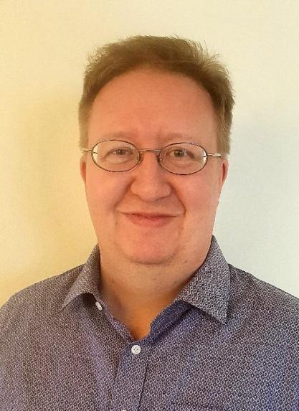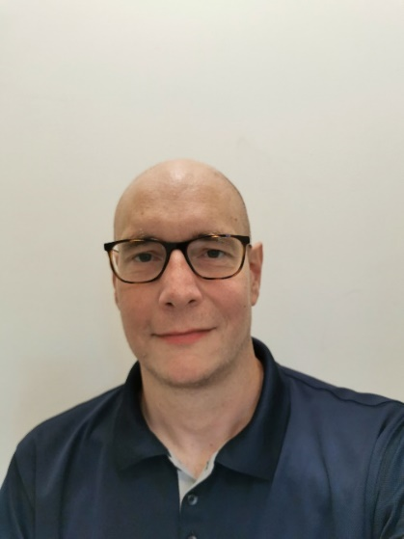

**David Andreasen**

Speech-to-Text Interpreter,  
Subtitler

[David.andreasen@skane.se](mailto:David.andreasen@skane.se)

**Ulf Norberg**

Lecturer in Translation Studies  
at Stockholm University,

Researcher in STTI

[ulf.norberg@su.se](mailto:ulf.norberg@su.se)

**Speeding up speech-to-text interpreting. On methods for systematizing the acquisition and usage of auto-expanding abbreviations when typing on the qwerty keyboard**

In the Scandinavian countries, at least half of the active speech-to-text interpreters type on the conventional keyboard (“qwerty”). When doing so, the use of so-called auto-expanding abbreviations for words and expressions enhances typing speed considerably. Until now, in Scandinavia and possibly in other countries as well, auto-expanding abbreviations have been created primarily impromptu, i.e., they have been created by individual interpreters when the need for an abbreviation has arisen. Often, they have been created arbitrarily, with a few common denominators that could be used as a mnemonic for retaining and recalling abbreviations while working, but without having a broader picture of the whole system of abbreviations in mind, or how these abbreviations should be taught.

In this paper, we discuss forms of systematization in the creation of auto-expanding abbreviations that could provide better results in terms of higher typing speed and better ergonomics for speech-to-text interpreters using the qwerty keyboard, and thereby provide higher interpreting quality. We take into account aspects of keyboard physiognomy and (lexical) statistics, but focus on how unity in signs per abbreviation, and morpheme placement on certain keys, could assist memory training and also finger movement usage.

**BIOS**

Ulf Norberg is a lecturer in Translation Studies at Stockholm University, Sweden. He has conducted research in Speech-to-Text Interpreting for more than 10 years, and has published six academic papers on STTI. Together with some colleagues, he has edited a book-length study on STTI that appeared in Swedish in 2022, *Skrivtolkning. Forskning och praktik* (Speech-to-text Interpreting. Research and Practice).

Always a fan of writing and languages, David Andreasen discovered the field of Speech-to-Text Interpreting while working as a subtitler. He currently works in interpretation services for the deaf and hard of hearing in Region Skåne, the southernmost part of Sweden.

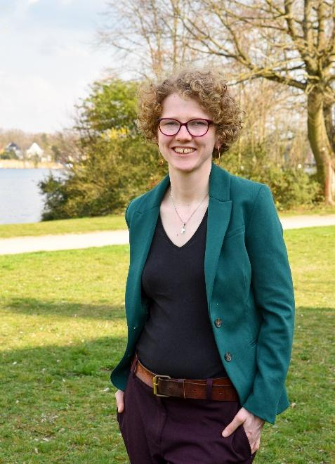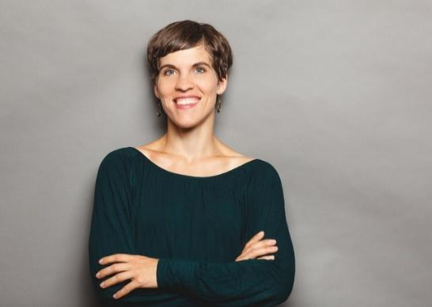

**Luisa Donachie-Bach**

Speech-to-Text Interpreter,

Live Subtitler,

Conference Interpreter (Greenterpreter)

[contact@greenterpreter.eu](mailto:contact@greenterpreter.eu)

**Nina Cisneros Arcos**

Founder and CEO of Orelon GmbH,

Speech-to-Text Interpreter,

Conference Interpreter

[post@orelon.de](mailto:post@orelon.de%20)

**Interpreting techniques and decisions in interlingual STTI - a practical experience**

Our team of two conference and speech-to-text interpreters has gathered a lot of experience in interlingual STTI (Mostly German<>English) in different settings - online, hybrid and on site. We are interested in how interlingual STTI is perceived in other countries and we want to hear from your experiences and get into an open exchange about the challenges and opportunities of interlingual STTI. We will give a short introduction, talk about our experiences, trips and tricks and then start an open discussion with the participants.

**BIOS**

Nina Cisneros Arcos is a Conference and Speech-to-text Interpreter for German, English, French and Spanish, founder and CEO of the Orelon GmbH, providing accessible and inclusive communication. She has many years of experience in interpreting in different settings and languages and offers workshops and training in inter- and intralingual STTI.

Luisa Donachie-Bach is a freelance M.A. Conference Interpreter ("Greenterpreter") based in Berlin, working with German, English and French and is certified as an STTI. In this area, she also works as a freelancer, mostly in event settings, intralingually and interlingually. For many years now, she has been regularly working for the public broadcasting TV channel for Berlin and Brandenburg as a Live Subtitler of the news and other TV formats as well as a subtitler in general.

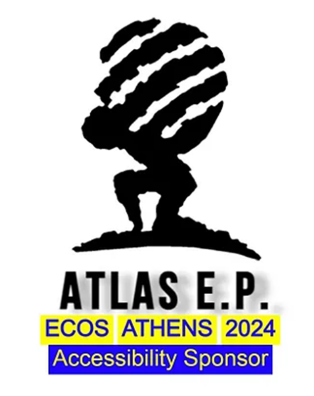**ECOS Athens 2024 Accessibility Sponsors**

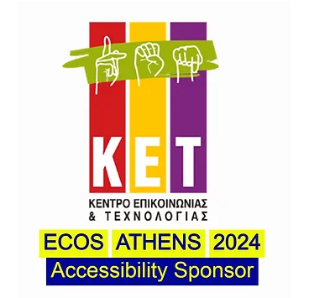

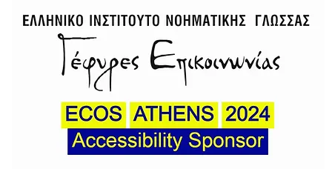

**ECOS Athens 2024 Sponsors and Supporters**

