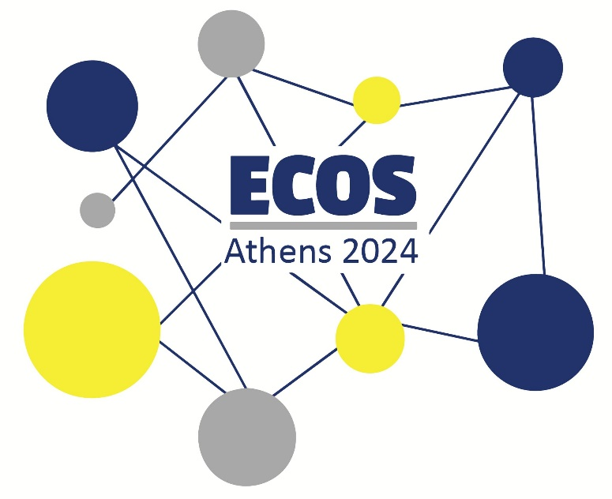

**ECOS ATHENS 2024 ● POSTER PRESENTATIONS**

**Prosvasis Universal Access Research and Innovation Lab for Technology, Society and the Arts** invites you to participate in ECOS 2024 by submitting a **poster presentation**. Poster presentations offer a visual and concise way to showcase your research and recent findings in the field of STTI. They provide an opportunity to engage with fellow attendees, discuss your findings, and receive valuable feedback.

**Guidelines for Poster Presentations**

* The recommended size for poster presentations is A0. Poster dimensions should not exceed 120×90 cm (height × width) and they should be designed in portrait orientation.
* Use legible font sizes. A minimum font size of 18-20 points is recommended. Choose a clear, easy-to-read font, such as Arial, Calibri, or Verdana. Ensure that your poster can be easily read from a distance.
* Organise your poster into clear sections, such as Introduction, Methodology, Results, and Conclusion. Use bullet points and concise language to present information clearly.
* Incorporate relevant images, diagrams, or charts to enhance your presentation and make it more engaging. Use high-quality visuals with appropriate labels and captions. Avoid overcrowding your poster with too many visual elements.
* Choose a colour scheme that is visually appealing and complements your content. Use contrasting colours for text and background to ensure readability.
* Clearly mention the authors, affiliations, and contact information at the bottom of the poster for attendees to reach out to you.
* Ensure your poster is printed on high-quality, durable material that can withstand transportation and display during the conference.

We believe that by following these guidelines, you can create an engaging and informative poster presentation that showcases your research in STTI effectively.

All posters will be displayed throughout the conference. Be available to discuss your poster during the designated presentation times. Engage with fellow attendees, listen to their feedback, and ask for their perspectives on your research. You may bring extra handout copies of your poster and any supplementary materials to share with interested attendees.

**Submission of Abstracts**

Abstracts should be submitted in English and contain no more than 500 words in length (excluding references and 3–5 keywords) and clearly state the research question(s) and/or goals of presentation. Please submit your proposal by filling in the [Online Form](https://docs.google.com/forms/d/e/1FAIpQLSdo3nI6dhKVTtSFmfvvXTeihLW_3kbpTglLRDqf695tkkk3lQ/viewform) and uploading your file in .DOCX format by April 30th 2024.

Make sure to check out our website for further information and updates: <https://www.prosvasisresearch.com/ecos-2024>

If you have any questions, you may contact us at [prosvasisresearch@gmail.com](mailto:prosvasisresearch@gmail.com).

We look forward to receiving your poster presentation and welcoming you to ECOS 2024!