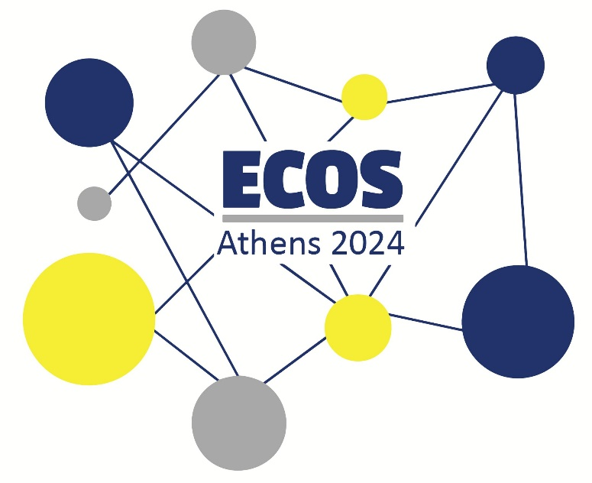

**ECOS ATHENS 2024 ● CALL FOR PAPERS**

**Prosvasis Universal Access Research and Innovation Lab for Technology, Society and the Arts** is proud to be the host of this year’s edition of the European Conference of Speech-to-Text Interpreters (ECOS) which will take place in **Athens, Greece**, **from July 26th to July 28th 2024**.

**Aim & Scope**

The aim of the ECOS conference is to bring together researchers, practitioners, language service providers and other stakeholders within the field of speech-to-text interpreting (STTI).

At the ECOS 2024, we focus on the recognition of STTI as a profession, the disambiguation of the field, its bonds with others fields, the interaction of Speech-to-Text Interpreters with the audience/users and the communities they serve, the technology behind STTI, and the relevant educational background needed for professionals in the area.

Being hosted in Greece, ECOS offers a great opportunity for the country to bring the need for STTI to the surface. It also hopes to provide the grounds for countries with no or very little representation in the field to share their stories and be involved in a constantly growing community of professionals.

ECOS aims to bring together professionals and the users of the service, and thus invites representatives of both to attend and present their topic in Athens.

**Topics**

We welcome conceptual, methodological, empirical, and practical contributions from various backgrounds relating to the conference, preferably with focus on the following topics:

* The status of STTI professionals among different countries, their involvement  
  with the users/communities they serve.
* Interpreting techniques and decisions in intralingual and interlingual STTI.
* Terminology linked to STTI regarding the profession and other fields.  
  Disambiguation of terms and comparison of terminology used among countries.
* The relationship between STTI and Sign Language Interpreting, methodologically  
  and practically.
* The relationship between STTI and Translation and/or Audiovisual Translation  
  in academia and in action.
* New tools and IT developments for STTI professionals.

Suggested approaches, tips and techniques.

* Perspectives by the users/audience. Tell us what you need and/or what you have experienced and/or want to experience through the service.
* Creative approaches to STTI in the Arts.

**Submission of Abstracts**

Submissions are invited for 30-minute presentations (20-minute presentation and 10-minute discussion) as well as for posters. Abstracts should be submitted in English and contain no more than 500 words in length (excluding references and 3–5 keywords) and clearly state the research question(s) and/or goals of presentation. Please submit your proposal by filling in the [Online Form](https://docs.google.com/forms/d/e/1FAIpQLSdo3nI6dhKVTtSFmfvvXTeihLW_3kbpTglLRDqf695tkkk3lQ/viewform) and uploading your file in .DOCX format by March 31st 2024.

**Key dates**

* Deadline for submission of abstracts: until March 31st 2024
* Notification of acceptance: until April 10th 2024
* Early-bird registration: from mid-February until March 2024
* Standard registration: from April until May 2024
* Late registration: from June until July 2024

Make sure to join the ECOS 2024 Groups on our website in order to keep up with news and updates: <https://www.prosvasisresearch.com/groups>

If you have any questions, you may contact us at [prosvasisresearch@gmail.com](mailto:prosvasisresearch@gmail.com).

We are looking forward to reading your proposals!