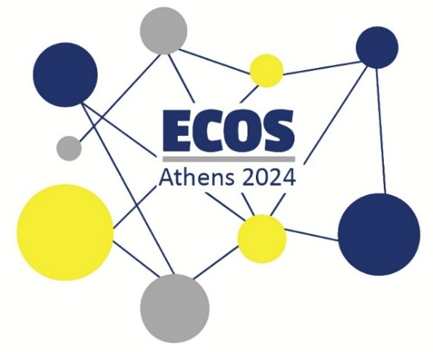

**European Conference of Speech-to-Text Interpreters**

**ECOS ATHENS 2024 ● Conference Programme**

**(ATHENS TIME ZONE)**

|  |
| --- |
| **Saturday, 20th of July 2024 at 11.00**  **Pre-conference Workshop on Accessibility (English - Online) Register** [**here**](https://forms.gle/Qo94CoZFC8xuRV2C7)**!** |
| **Monday, 22nd of July 2024 at 18.30**  **Pre-conference Workshop on Accessibility (Greek – Online) Register** [**here**](https://forms.gle/Qo94CoZFC8xuRV2C7)**!** |

|  |
| --- |
| **Friday, 26th of July 2024**  **Registration: 10.00 -10.30**  **Welcoming – Introduction: 10.30 – 11.00 Emmanouela Patiniotaki (Prosvasis, ATLAS E.P.)**  **Keynote speech on STTI training: 11.00 – 12.00**  **STTI training - teaching the undefined, defining the untaught Carlo Eugeni (Leeds University, UK)**  **Coffee Break - Networking**  **Morning Session on STTI: 12.30 – 13.15**  **What makes intralingual interpreting “interpreting”? Definitions, opinions, and beyond in interpreting studies, professional practice, and international standards. Daniela Eichmeyer-Hell (University of Vienna, ÖSDV, Schriftdolmetscher Bayern)**  **Lunch break - Networking  Afternoon Sessions on STTI & the world: 14.00 – 16.00**  **Viewing Interlingual Live Subtitling in China from Workflows Qing Han (University of Bristol)**  **Chord System for QWERTZ/Y – Tests in Czech Republic Tomáš Portych (Czech Union of the Deaf)**  **Round table on STTI practices around the world** |
| **Workshop: STTI basic typing skills for beginners 16.30-18.30 Register** [**here**](https://forms.gle/Qo94CoZFC8xuRV2C7)**!** |
| **Conference Dinner (all registered participants): 19.30** |
| **Saturday, 27th of July 2024**  **Keynote speech on STTI and AVT: 10.00 – 11.00**  **Bonds among Interpreting, AVT and Disability**  **Emmanouela Patiniotaki (ATLAS E.P., Prosvasis)**  **Morning Session on STTI and Disability: 11.00 – 12.00**  **Deafblind User Experience: Determinants and effects of the use of speech-to-text interpreting at events and meetings Anna Nawrot (University of Silesia in Katowice) & Grzegorz Kozłowski (Polish Foundation of the Hard of Hearing People)**  **Coffee Break - Networking**  **Keynote speech on STTI and AI: 12.15 – 13.15**  **What does AI bring to STTI?  Theodoros Sakalidis (STTI professional, member of ÖSDV)**  **Lunch break - Networking  Afternoon Sessions on STTI research & practice: 14.00 – 16.00**  **Visual Attention during Speech-to-Text Interpreting: An Eye-Tracking Study Julia Matzenberger (ÖSDV)**  **Speeding up speech-to-text interpreting. On methods for systematizing the acquisition and usage of auto-expanding abbreviations when typing on the qwerty keyboard Ulf Norberg (Institute for Interpreting and Translation, Stockholm University), David Andreasen (Region Skåne)**  **Interpreting techniques and decisions in interlingual STTI – practical experience Nina Cisneros Arcos & Luisa Donachie-Bach (BSD, VKD, BDÜ)** |
| **Workshop: Interlingual STTI for professionals 16.30-18.30 Register** [**here**](https://forms.gle/Qo94CoZFC8xuRV2C7)**!** |
|  |
| **Sunday, 28th of July 2024**  **Keynote speech on STTI evolution: 9.30 – 11.30**  **STTI in Austria – tracing the pathway from emerging profession to established accessibility service Judith Platter (University of Vienna, ÖSDV)**  **Conference take-aways – Where do we go next? Emmanouela Patiniotaki, Judith Platter**  **Coffee Break**  **Bring STTI to least used languages (Greece & the others): 12.00 – 13.30 Chair: Mike Nugent, Daniela Eichmeyer-Hell**  **Invited:**  **European Federation of Hard of Hearing People, Hellenic Broadcasting Corporation, National Federation of the Deaf, Greek Institute of the Deaf, National Confederation of Disabled People Greece, Deaf and hard-of-hearing users.** |