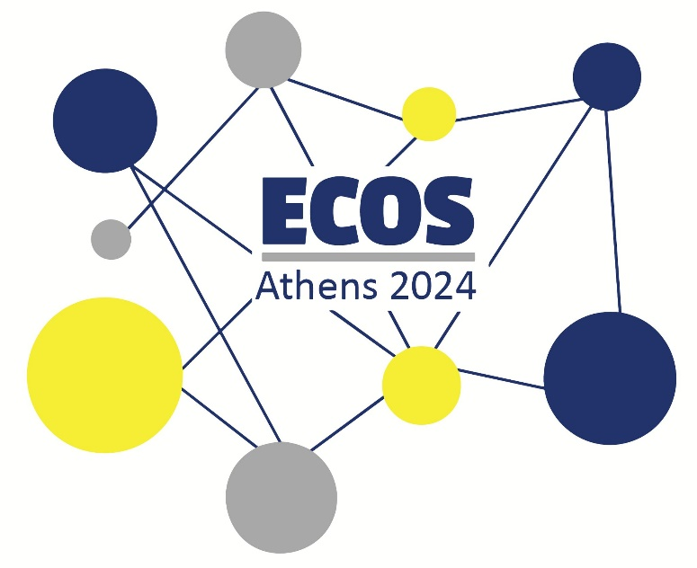

**ECOS ATHENS 2024 ● PROSVASIS INNOVATION AWARD**

**Prosvasis Universal Access Research and Innovation Lab for Technology, Society and the Arts** invites you to participate in ECOS 2024 with a proposal that will win the PROSVASIS INNOVATION AWARD! You can read about the award below.

**Call for Audience and Innovators to attract attention!**

As part of the ECOS Athens 2024 aim to bring society close to the STTI professionals community, we are also inviting users of the service for purposes of sensory access to present the technology or the service they use that makes their communication easier in everyday life.

Users’ **inventions** will be given priority, and each participant in this session will have 10 minutes to present their preferred tool/service. Remember! Your idea could be a users’ interpreting setup, a combination of tools for access, an application you created etc.

**Submission of Proposals**

Proposals should be submitted in English or Greek and contain no more than 500 words in length (excluding references and 3–5 keywords) and clearly state the innovation presented. Please submit your proposal by filling in the [Online Form](https://docs.google.com/forms/d/e/1FAIpQLSdo3nI6dhKVTtSFmfvvXTeihLW_3kbpTglLRDqf695tkkk3lQ/viewform) as a proposal and uploading your file in .DOCX format by May 31st 2024.

Make sure to check out our website for further information and updates: <https://www.prosvasisresearch.com/ecos-2024>

The winner(s) of the PROSVASIS INNOVATION AWARD will receive benefits from our Lab and free membership to our Scientific/Users’ Team.

If you have any questions, you may contact us at [prosvasisresearch@gmail.com](mailto:prosvasisresearch@gmail.com).

We look forward to receiving your proposal and welcoming you to ECOS 2024!