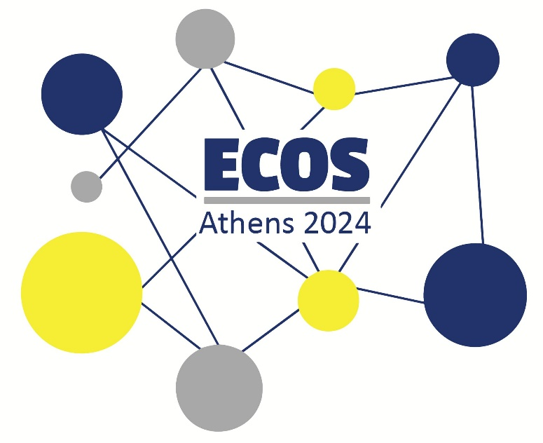

**ECOS ATHENS 2024 ● WORKSHOPS**

**Prosvasis Universal Access Research and Innovation Lab for Technology, Society and the Arts** invites you to participate in ECOS 2024 by presenting a **workshop**. A workshop will give you the opportunity to share your expertise and insights, fostering a stimulating learning environment for attendees.

**Guidelines for Workshops**

* Workshops should have clear goals and objectives, focusing on practical skills, current practices, or innovative approaches in STTI. They should provide attendees with hands-on experience, knowledge, or tools to enhance their professional development.
* Workshops can be designed in various formats, such as lectures, discussions, hands-on exercises, or a combination of these. They should be up to 90 minutes in duration to ensure an engaging and focused experience for participants.
* Workshop proposals should indicate any specific technical requirements, such as audiovisual equipment, internet access, or special software. The organisers will try to provide the necessary basic equipment, but presenters may need to bring their own materials or devices.
* Workshop presenters should be experts or professionals with extensive experience in the topic they propose. They should demonstrate clear communication and facilitation skills to ensure an effective learning experience for attendees.
* Workshops should be designed to be inclusive and accessible for all participants. This includes providing clear language, accommodating different learning styles, and ensuring materials are available in accessible formats.
* Workshop presenters should be prepared to collect feedback from participants to evaluate the effectiveness of their workshop and make improvements for future presentations. The organizers may also request feedback from attendees to assess the overall quality and relevance of the workshops offered at the conference.
* To ensure the integrity of the conference, workshop presenters should disclose any potential conflicts of interest related to the topic they propose. This may include financial ties, personal relationships, or other circumstances that could influence their presentation.

**Submission of Abstracts**

Abstracts should be submitted in English and contain no more than 500 words in length and clearly describe the workshop’s content, methodology and expected outcomes as well as state the target audience and any prerequisite knowledge or skills required for participation. Please submit your proposal by filling in the [Online Form](https://docs.google.com/forms/d/e/1FAIpQLSdo3nI6dhKVTtSFmfvvXTeihLW_3kbpTglLRDqf695tkkk3lQ/viewform) and uploading your file in .DOCX format by April 30th 2024.

The selection process will be based on the relevance, innovation, clarity, and potential impact of the proposed workshop, as well as the qualifications and experience of the presenter(s).

Make sure to check out our website for further information and updates: <https://www.prosvasisresearch.com/ecos-2024>

If you have any questions, you may contact us at [prosvasisresearch@gmail.com](mailto:prosvasisresearch@gmail.com).

Do not hesitate to share your passion for the field by submitting your captivating and innovative workshop proposal. We eagerly anticipate your contribution to the conference!